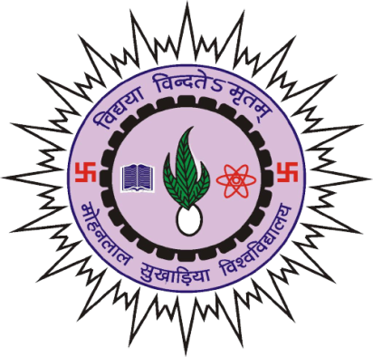

**INSTITUTE OF ENGINEERING & TECHNOLOGY MLSU**

**Session 2022-23**

**A DBMS Project report on**

**BANK MANAGEMENT SYSTEM**

**Submitted To: Submitted By:**

Akanksha Joshi Shivam Chouhan

Faculty, Department of

Computer Science Engineering